How To Install Cockpit

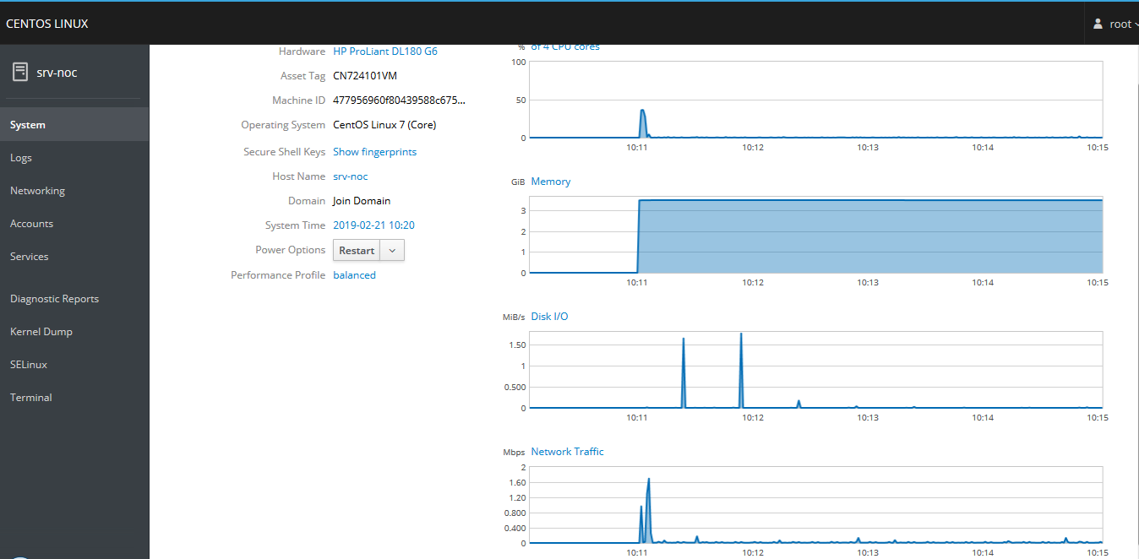

Install Cockpit Package
[root@srv-noc ~]# yum install cockpit

Enable service cockpit
[root@srv-noc ~]# systemctl enable --now cockpit.socket

Add Firewall Rule
[root@srv-noc ~]# firewall-cmd --permanent --zone=public --add-service=cockpit

Reload Service Firewall
[root@srv-noc ~]# firewall-cmd --reload

